EXPT NO:1 | Introduction to Python Libraries and Dataset Preprocessing
DATE: 21.01.2026 | Introduction to Python Libraries and Dataset Preprocessing

PRE-LAB QUESTIONS (PROVIDE BRIEF ANSWERS TO THE FOLLOWING QUESTIONS)

- Which Pandas function is used to read a CSV file and what parameters does it accept?
- What is the difference between head() and tail() in Pandas?
- Which Matplotlib function is used to plot a line chart?
- What information do info() and describe() provide about a dataset?
- Why should data be visually inspected before further analysis?

IN-LAB EXERCISE
OBJECTIVE: Explore and preprocess a dataset using Python.
SCENARIO 1: E-commerce Sales Data
Analyze a sample e-commerce dataset to understand product categories, sales trends, and missing information.
Dataset (Kaggle – Public):
https://www.kaggle.com/datasets/carrie1/ecommerce-data

IN-LAB TASKS:
- Import necessary Python libraries.
- Load the dataset into a Pandas DataFrame.
- Inspect dataset using head(), tail(), info(), and describe().
- Check for missing values.
- Visualize sales per product using bar and line charts.
OUTPUT:
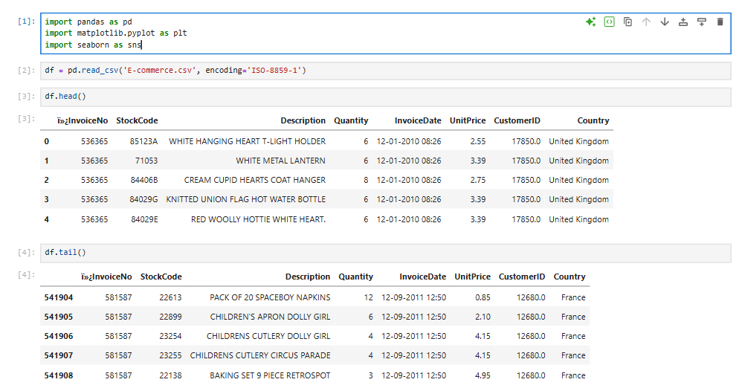
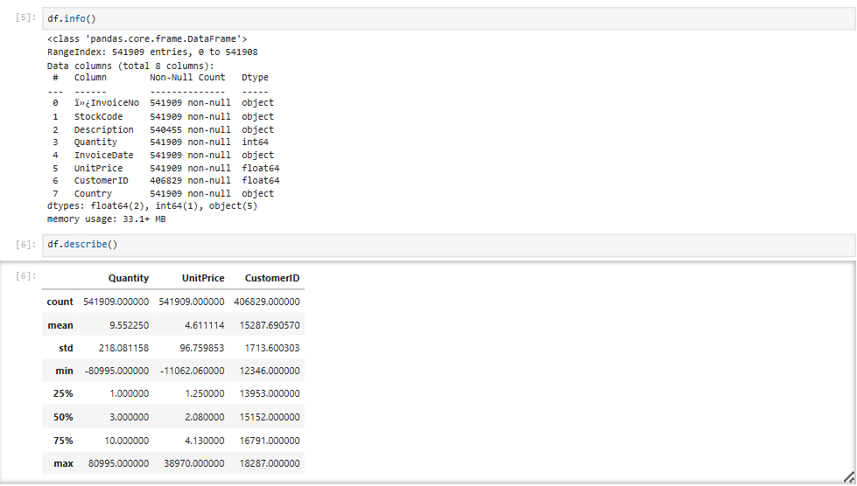

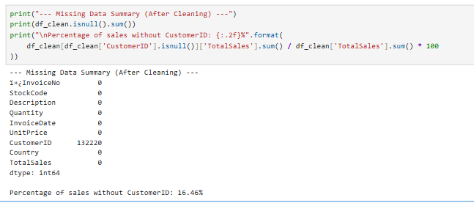
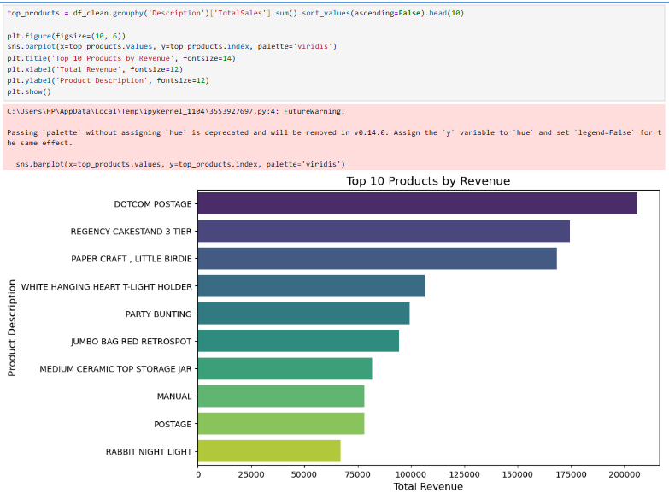
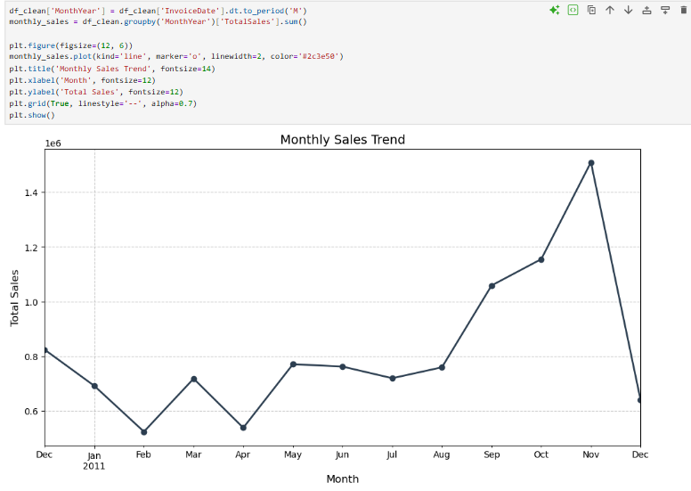

SCENARIO 2: Hospital Patient Records
Examine a patient dataset to identify missing health metrics and visualize distributions.
Dataset (Kaggle – Public):
https://www.kaggle.com/datasets/uciml/pima-indians-diabetes-database

IN-LAB TASKS:
- Load the dataset into Pandas.
- Explore data structure and missing values.
- Visualize glucose levels and age distribution using histograms and boxplots.
- Identify patterns in health metrics.
OUTPUT:
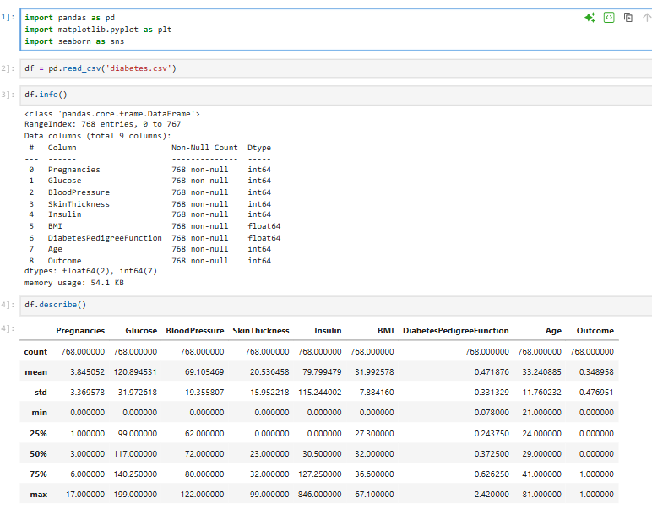
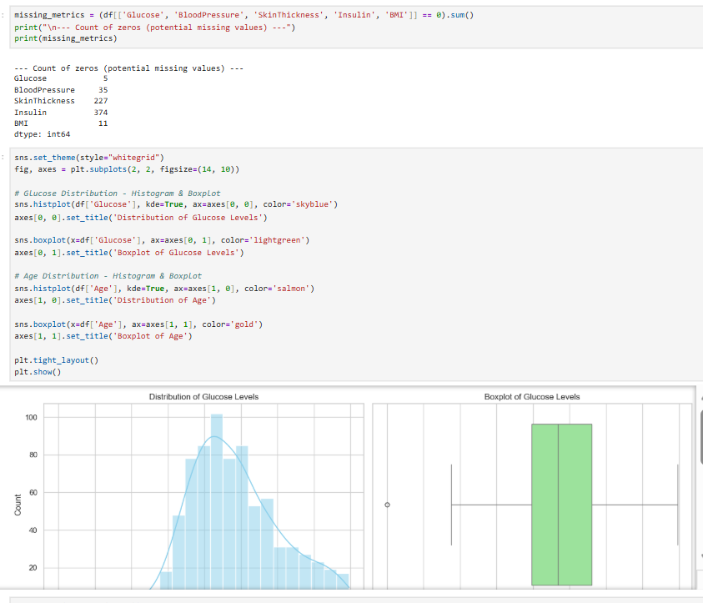
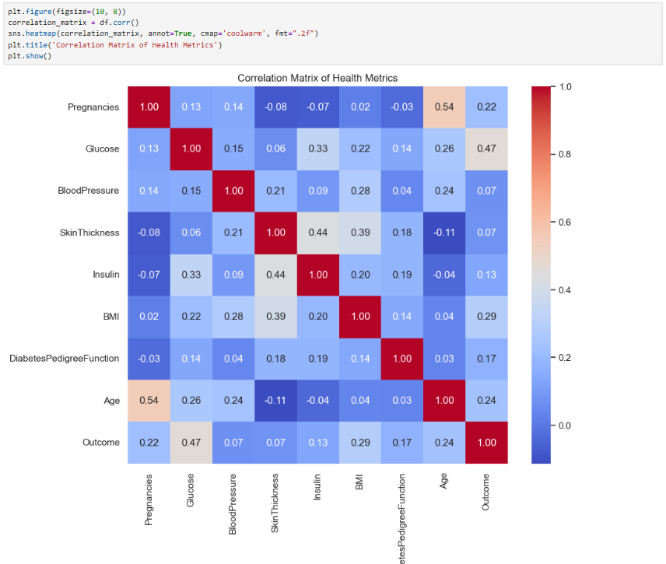
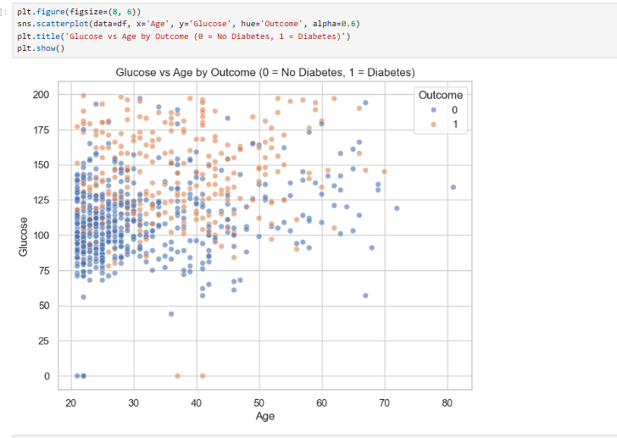

SCENARIO 3: Housing Dataset
Investigate a housing dataset for missing features and relationships between house attributes.
Dataset (Kaggle – Public):
https://www.kaggle.com/datasets/harishkumardatalab/housing-price-prediction

IN-LAB TASKS:
- Load the dataset and inspect columns.
- Detect and summarize missing values.
- Visualize correlations between numerical features using scatter plots and heatmaps.
- Interpret trends for price prediction.

OUTPUT:
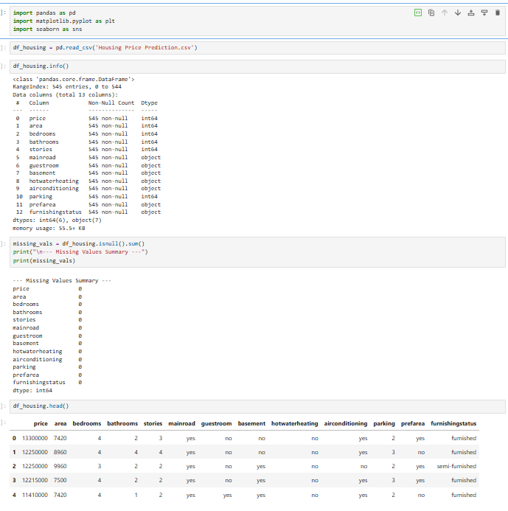
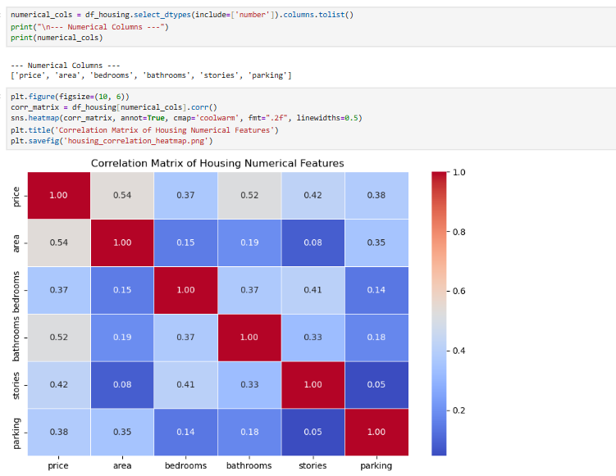
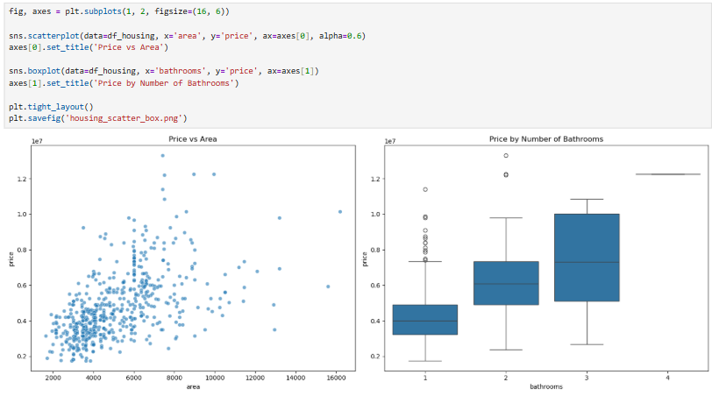
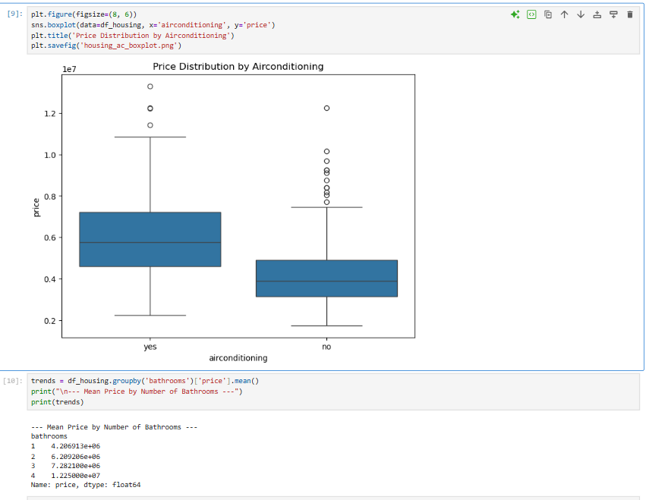
SCENARIO 4: Banking Customer Data
Analyze banking data to detect missing account information and understand customer demographics.
Dataset (Kaggle – Public):
https://www.kaggle.com/datasets/ajay1735/customer-personality-analysis
IN-LAB TASKS:
- Import dataset into Pandas.
- Examine structure, null values, and column types.
- Visualize age, income, and spending patterns using bar and box plots.
- Summarize insights from visualizations.

(CODE: CONATAINS STUDENT ROLL NOS
SCREENSHOT OF CODE
SCREENSHOT OF OUTPUT)

OUTPUT:
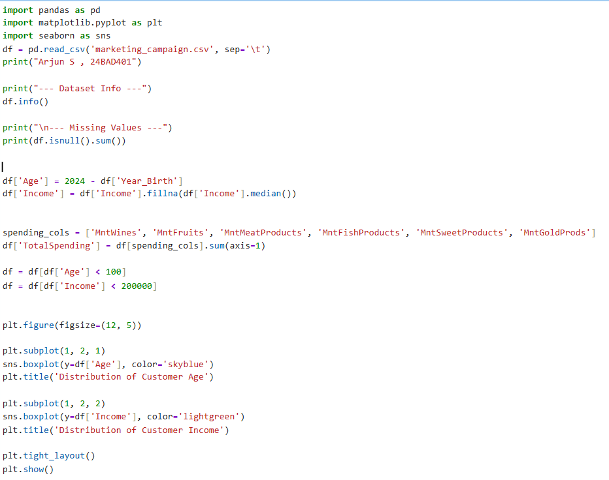
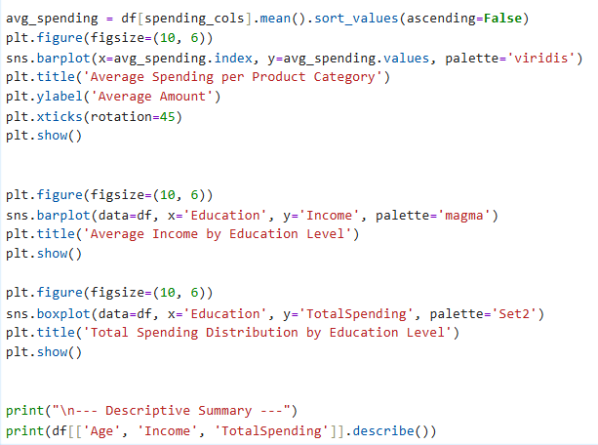

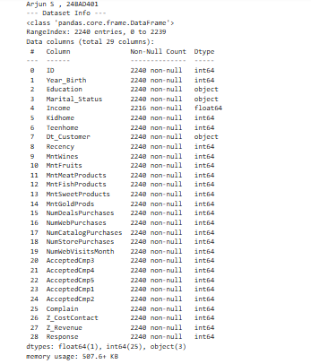
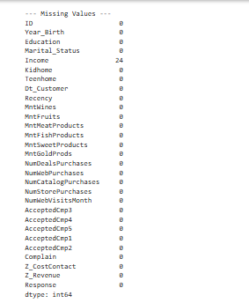
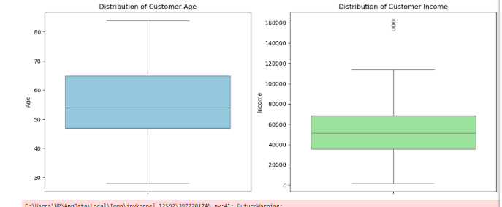

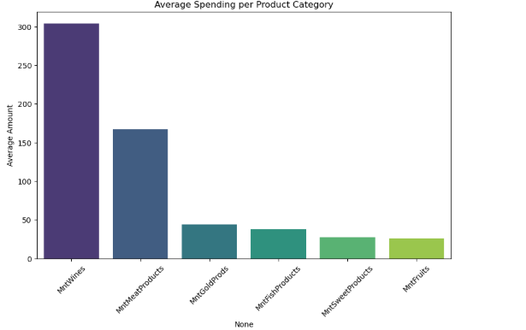

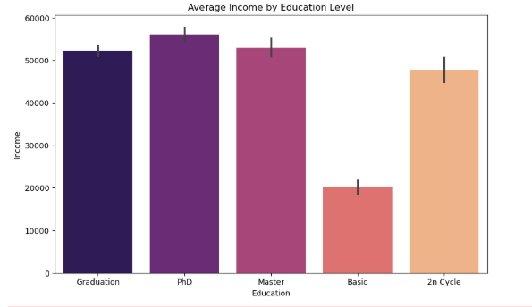

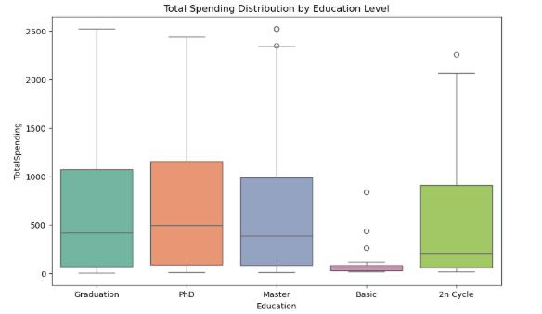
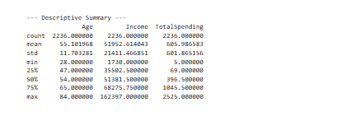

POST-LAB QUESTIONS (PROVIDE BRIEF ANSWERS TO THE FOLLOWING QUESTIONS)

Scenario 1: Which columns had missing values and how did it affect e-commerce sales analysis? Scenario 2: How were missing health metrics handled and what trends were observed?
Scenario 3: Which housing features were missing and how did visualization help in understanding relationships?
Scenario 4: What patterns in customer demographics were observed after preprocessing, and how can they guide banking decisions?

ASSESSMENT
Description | Max Marks | Marks Awarded
Pre Lab Exercise | 5
In Lab Exercise | 10
Post Lab Exercise | 5
Viva | 10
Total | 30
Faculty Signature

